CHEMICAL ENGINEERING TRANSACTIONS  VOL. , 2024 | A publication of
The Italian Association
of Chemical Engineering
Online at www.cetjournal.it

Guest Editors: Leonardo Tognotti, Rubens Maciel Filho, Viatcheslav Kafarov
Copyright © 2024, AIDIC Servizi S.r.l.
ISBN 979-12-81206-09-0; ISSN 2283-9216

Revalorization of cheese whey through a biorefinery scheme
Valeria Caltzontzin-Rabell, Claudia Gutiérrez-Antonio*
Universidad Autónoma de Querétaro, Facultad de Ingeniería, Campus Amazcala, Carretera a Chichimequillas s/n Km 1, Amazcala, El Marqués, Querétaro, 76265, México.
claugtez@gmail.com

Cheese whey is a by-product of cheese production. This waste, of which almost 145 million tons are generated annually, is of interest because of the management it requires; improper handling can cause adverse environmental impacts due to its high organic load and nutrient content. Although the treatment depends on its origin, anaerobic digestion is the most widely used from which methane can be obtained. In this way, several proposals for its treatment through biorefinery schemes have been proposed. However, treatment with insects and their inclusion in biorefinery schemes, specifically with black soldier fly larvae (Hermetia illucens), has not been proposed. Black soldier fly larvae (BSFL) have stood out for their effectiveness in treating large quantities of waste. Once BSFL biotransform waste into larval biomass, they are harvested for feed or their oil is extracted and transformed into biodiesel. Other products of interest include some peptides with antioxidant capacity and compounds with antimicrobial activity. To our knowledge, there are no reports on the treatment of cheese whey with BSFL; therefore, this work aims to propose a biorefinery scheme to convert this waste into value-added using BSFL. After reviewing the literature, a value-added product (antimicrobial extract) and a biofuel (biodiesel) were selected. Regarding the antimicrobial extract, activity against Salmonella spp. bacteria was observed. Finally, biodiesel was obtained from the fat. It is possible to get at least one value-added product and biofuel in a biorefinery scheme using BSFL as a biological treatment.
  - Introduction
Global technological growth and development have been based on the exploitation of resources, which, although they have managed to support this model for years, are beginning to decrease in quantity. In this sense, the circular economy concept has been proposed to promote sustainable development. Among the objectives of the circular economy are to keep the extracted raw materials as long as possible in the production chain and reduce waste generated as well as greenhouse gas emissions. In this sense, waste and by-products must be recycled or reused (Londoño and Cabezas, 2021).

Cheese whey is a by-product of milk processing into cheese that is often discarded as waste. Approximately 1 kilogram of cheese produces about 9 kilograms of whey (Charalambous & Vyrides, 2021). Around 145 million tons are generated annually (Caltzontzin-Rabell et al., 2021). Although cheese whey composition depends on the type of cheese or source of the milk, it is generally composed of water (93-94%), dry matter (proteins [0.6-0.8%] and fats [0.4-0.5%]), and lactose (4-5%) (Ponist et al., 2021). Due to this composition, its disposal must be taken care of, otherwise improper management can result in effluent contamination (Ganju and Gogate 2017).

Among the most commonly used methods to treat dairy effluents are anaerobic processes, which require long times to ensure good treatment (Tirado et al., 2018) and from which methane can be obtained. A biological treatment with microalgae has also been proposed as an alternative for its management and generation of products of interest (Lappa et al., 2019).

In this way, there are also proposals for treatment through the integration of processes in biorefinery schemes. A biorefinery described by Kopsahelis et al. (2018) used wine lees and cheese whey as raw materials to produce ethanol, chemicals, animal feed, and oil. Another research conducted by Hemalatha et al. (2019) proposed dairy wastewater treatment under a biorefinery scheme using microalgae. The products obtained were oil and fermentable sugars to produce bioethanol. Both papers highlight the importance of optimizing the biorefinery design. However, treatment with insects and their inclusion in biorefinery schemes, specifically with soldier fly larvae (Hermetia illucens), has not been proposed.

Black soldier fly larvae have been proposed as an alternative to waste management due to their high efficiency in converting them into a biomass rich in molecules of interest such as fat (rich in saturated fatty acids), protein (to feed chicken or fish) (Aguilar-Murguía et al., 2022; Mshayisa et al., 2022), and even antimicrobial compounds (Elhag et al., 2017). Therefore, various products of interest can be obtained from this insect. Literature has explored different residues (bread, food waste, fish, and even mussels) to rear BSFL (Ewald et al., 2019). However, cheese whey has not been investigated as a single process or under a biorefinery scheme. Therefore, this work presents a biorefinery design for cheese whey using a biological process, such as BSFL (Figure 1).

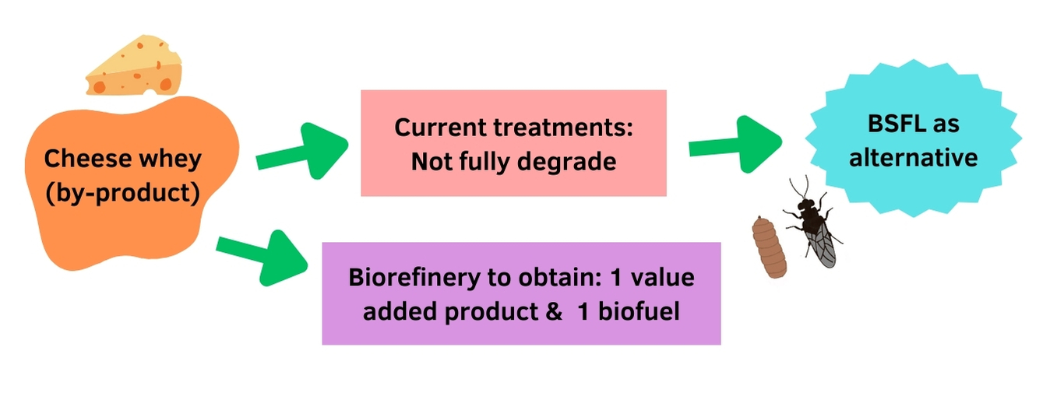
Figure 1: Objective of the project.

2. Materials and Methods

2.1 BSFL rearing
Cheese whey was mixed with Gainesville diet (75:25) and was given to five-day-old BSFL for conversion. The room conditions were 32 °C and 60% and 70% relative humidity. BSFL were obtained from a colony of the Faculty of Engineering of the Autonomous University of Queretaro (El Marques, Queretaro, Mexico). Cheese whey was obtained from the Dairy Pilot Plant, also located at UAQ. It was recovered the same day it was generated and kept at room temperature. The larvae were reared in cheese whey for 11 days, and every 2 days, they were collected for weight, length, and width recording. Larvae biomass and residual material (frass) were also weighed at the end of the experiment (Figure 2).

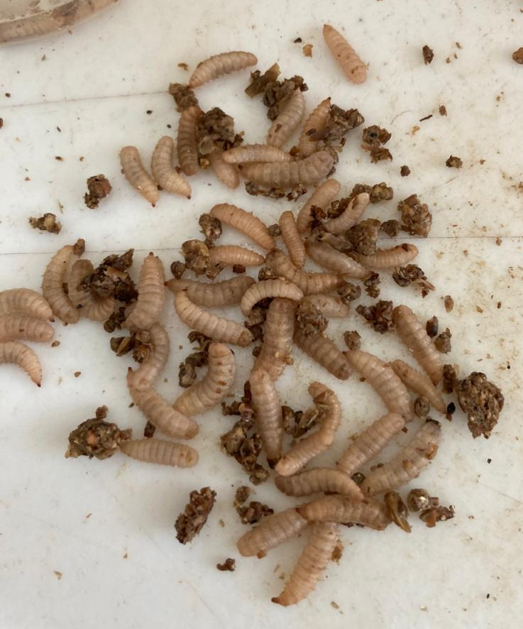
Figure 2: Black soldier fly larvae and residual material (frass).
On the eleventh day, BSFL were placed in a freezer for death, then, were dried at 65 °C for 72 h and finally, grounded (Figure 3).
Figure 3: BSFL dried and grounded.
2.2. Obtaining products of interest (obtaining of experimental data)
To obtain the antimicrobial extract, grounded BSFL was sonicated with methanol and then followed by centrifugation. The resulting supernatant was utilized for the preparation of diffusion disks. Subsequently, inhibition halo tests were conducted to validate its effectiveness against Salmonella spp. (Figure 4).
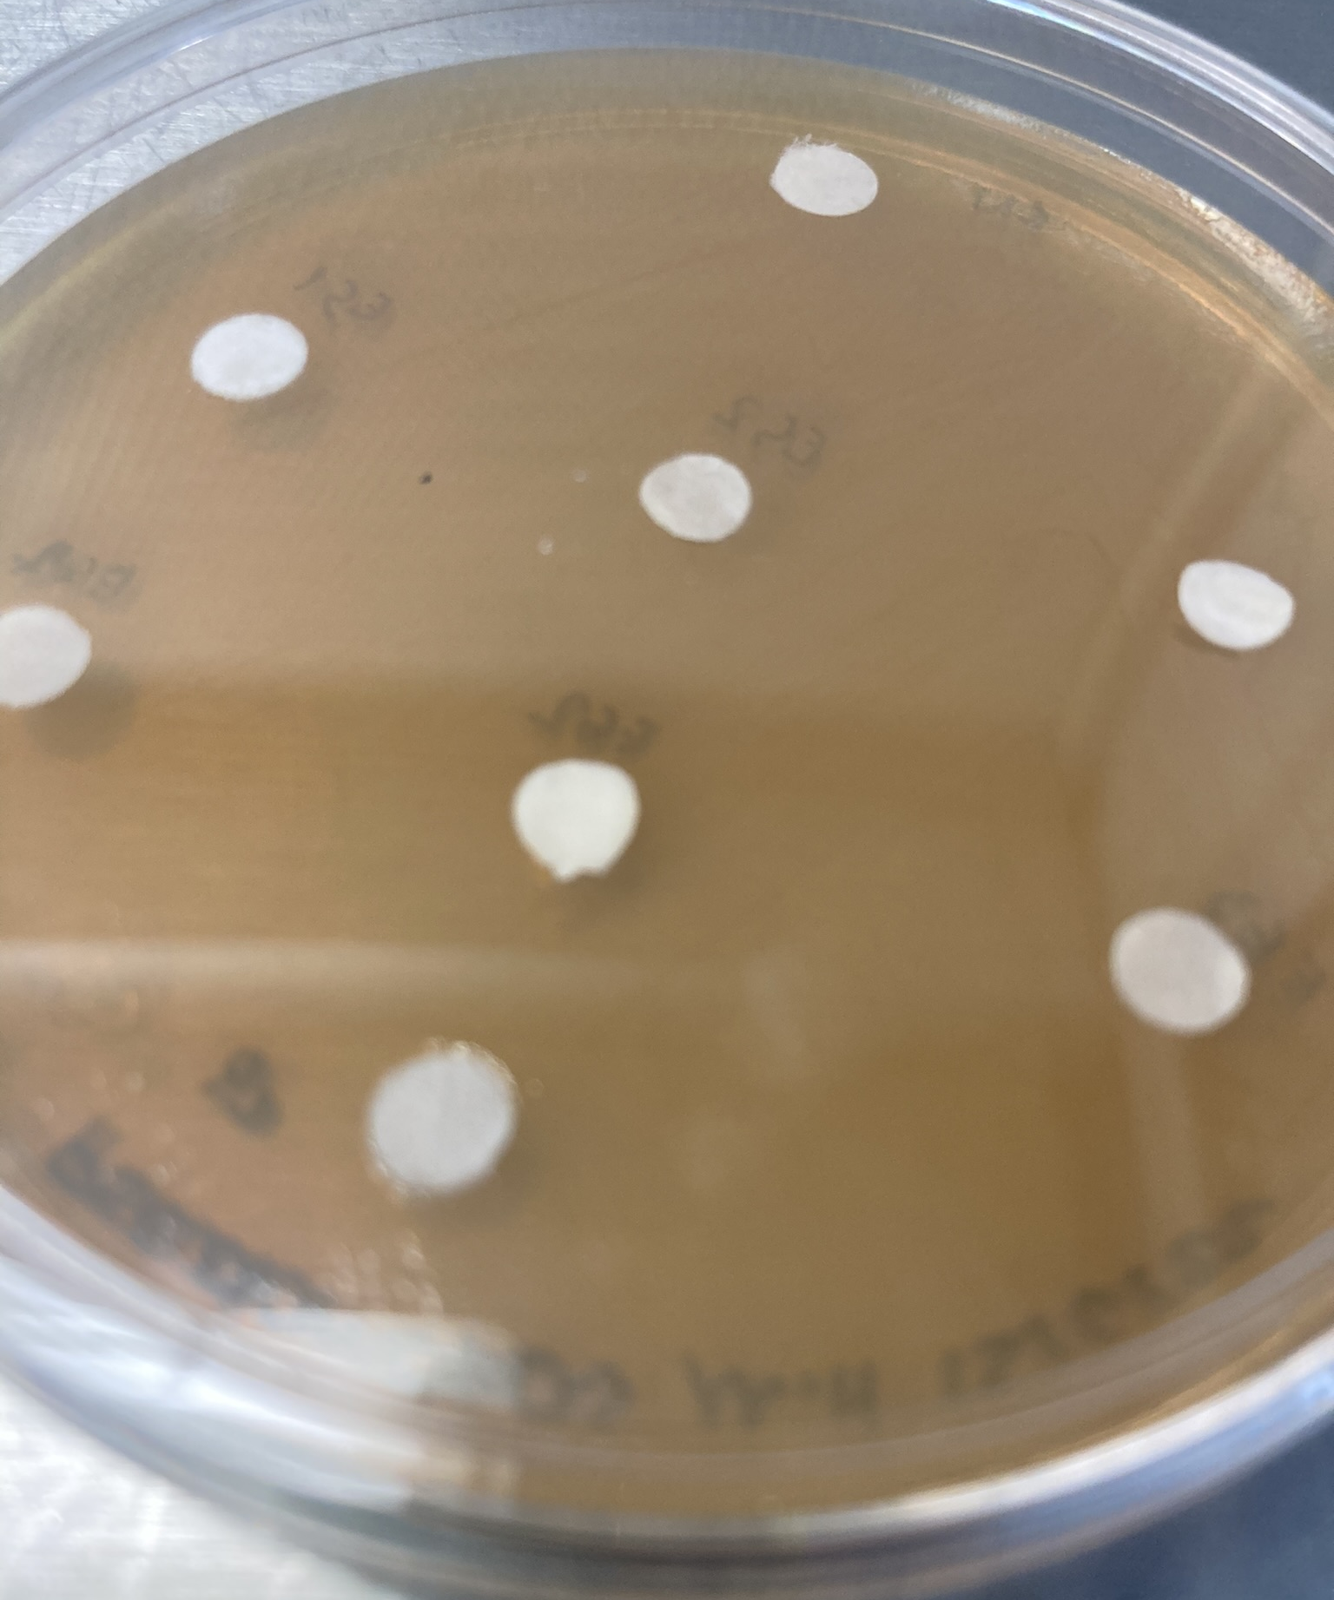
Figure 4. Inhibition halo test.
After obtaining the antimicrobial extract, the fat of the grounded BSFL was extracted with Soxhlet equipment using hexane as solvent and characterized using a Gas Chromatography-Mass Spectrometer (GC-MS). The extracted fat was subsequently subjected to acid transesterification (using methanol and sulfuric acid), a key step in converting the raw material into biodiesel. Biodiesel was finally washed with distilled water and weighed.

This dual-product approach showcases the versatility of the biorefinery concept, efficiently transforming waste into both high-value bioproducts and sustainable biofuel.

2.3 Designing of biorefinery
Based on the experimental data obtained in the laboratory, the necessary calculations were made to determine the quantities extracted of the products of interest. Parameters such as BSFL growth rates, nutrient consumption, and the yield of valuable products were incorporated into the model. This design endeavor provides a theoretical framework for the biorefinery and a useful tool for modeling, optimizing, and scaling up the process for potential industrial applications.

3. Results and discussion
The model of the proposed biorefinery is shown in Figure 4. As can be seen, it is possible to obtain at least one value-added product (antimicrobial) and one biofuel (biodiesel) using this biorefinery.

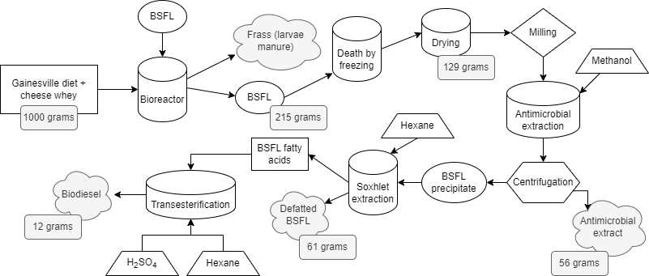

Figure 4: Model of the proposed cheese whey biorefinery.
This model indicates the viability and efficacy of utilizing BSFL as a biological treatment for cheese whey. Considering 1 kilogram of waste (cheese whey mixed with Gainesville diet), which uses 500 larvae, approximately 215 grams of BSFL can be obtained in fresh weight. Regarding the products of interest, of the 215 grams of larvae in fresh weight, about 129 grams of dried larvae were obtained; from this, 56 grams of antimicrobial extract diluted in methanol and 12 grams of biodiesel were obtained; the rest can be used as feed for animals such as chicken or fish. Other products that can be obtained and should be studied in future work are frass, a residue of the larvae that has been studied for its great nutritional value for plants, and chitin, an important molecule in insects and has a high commercial value. Furthermore, an economic analysis is required to assess whether the proposal is profitable since chemicals such as hexane, methanol, and sulfuric acid are required.

Comparing this proposal with two alternative biorefinery concepts tailored for cheese whey, it can be observed that the generated products of interest are different from those reported. For example, in 2018, Kopsahelis et al. described in their biorefinery proposal the possibility of obtaining ethanol, antioxidants, tartrate salts, animal feed, oil, and protein if cheese whey is mixed with wine lees. Hemalatha et al. (2019) also proposed a biorefinery with dairy residues using microalgae, which accumulate fat. Among the products proposed are oils, carbohydrates, and water for irrigation. It is noteworthy that in both instances, the need for additional research is underscored to enhance the extraction efficiency of these products—an inherent challenge encountered by any proposed biorefinery seeking optimal output.

4. Conclusions
The results obtained from the laboratory process validate the feasibility and efficiency of the proposed biorefinery scheme, substantiating its potential as a sustainable solution for cheese whey valorization. The biofuel, derived from the transesterification of fat extracted from BSFL, contributes to the overarching goal of achieving a sustainable energy source. This innovative approach addresses the environmental challenges associated with cheese whey waste and contributes to the Circular Economy concept by transforming waste into valuable resources. The dual benefits of obtaining high-value products and sustainable biofuel underscore the economic and environmental sustainability of the proposed biorefinery scheme. Further research and scaling efforts will refine this design, unlocking even greater potential for waste valorization and contributing to a more resilient and eco-conscious global community.

Nomenclature
BSFL- black soldier fly larvae
Acknowledgments
The authors thank the Universidad Autónoma de Querétaro and the Consejo Nacional de Humanidades, Ciencia y Tecnología CONAHCYT (México) for their support for this work through project FOPER-2021-FIN02497 and grant 2020-000013-01NACF, respectively. The authors also thank the Metabolites and Nanocomposites Laboratory of the Universidad Autónoma de Querétaro for their support in carrying out the analyses presented.
References
Aguilar-Murguía D.M., Martínez-Guido S. I., García-Trejo J.F., Hernández S., Gutiérrez-Antonio C. 2022, Optimal configuration of a biodiesel production network using oil from black soldier fly larvae, Computer Aided Chemical Engineering 51, 901-906.
Caltzontzin-Rabell V., Gutiérrez-Antonio C., García-Trejo J.F., and Feregrino-Pérez A. A., 2021, A review on processes for whey and dairy wastewater treatment and valorization. XVII International Engineering Congress (CONIIN) 1-6.
Charalambous, P., Vyrides, I., 2021, In situ biogas upgrading and enhancement of anaerobic digestion of cheese whey by addition of scrap or powder zero-valent iron (ZVI), Journal of Environmental Management, 280.
Elhag O., Zhou D., Song Q., Soomro A.A., Cai M., Zheng L., Yu Z., Zhang J., 2017, Screening, expression, purification and functional characterization of novel antimicrobial peptide genes from Hermetia illucens (L.), PLoS One 12, 1–15.
Ewald N., Vidakovic A., Langeland M., Kiessling A., Sampels S., Lalander C., 2020, Fatty acid composition of black soldier fly larvae (Hermetia illucens) – Possibilities and limitations for modification through diet, Waste Management 102, 40–47.
Ganju S., Gogate P.R., 2017, A review on approaches for efficient recovery of whey proteins from dairy industry effluents, Journal of Food Engineering 215, 84–96.
Giannetto A., Oliva S., Ceccon Lanes C. F., de Araújo Pedron F., Savastano D., Baviera C., Parrino V., Lo Paro G., Spanò N. C., Cappello T., Maisano M., Mauceri A., Fasulo S., 2020, Hermetia illucens (Diptera: Stratiomydae) larvae and prepupae: Biomass production, fatty acid profile and expression of key genes involved in lipid metabolism, Journal of Biotechnology 307, 44-54.
Hemalatha M., Sravan J. S., Min B., Venkata Mohan S., 2019, Microalgaebiorefinery with cascading resource recovery design associated to dairy wastewater treatment, Bioresource Technology 284, 424–429.
Kopsahelis N., Dimou C., Papadaki A., Xenopoulos E., Kyraleou M., Kallithraka S., Kotseridis Y., Papanikolaou S., Koutinas A.A., 2018, Refining of wine lees and cheese whey for the production of microbial oil, polyphenol-rich extracts and value-added co-products, Journal of Chemical Technology and Biotechnology 93, 257–268.
Kopsahelis N., Dimou C., Papadaki A., Xenopoulos E., Kyraleou M., Kallithraka S., Kotseridis Y., Papanikolaou S., Koutinas A.A., 2018, Refining of wine lees and cheese whey for the production of microbial oil, polyphenol-rich extracts and value-added co-products, Journal of Chemical Technology and Biotechnology 93, 257–268.
Kopsahelis N., Dimou C., Papadaki A., Xenopoulos E., Kyraleou M., Kallithraka S., Kotseridis Y., Papanikolaou S., Koutinas A.A., 2018, Refining of wine lees and cheese whey for the production of microbial oil, polyphenol-rich extracts and value-added coproducts, Journal of Chemical Technology and Biotechnology 93, 257-268.
Lappa I.K., Papadaki A., Kachrimanidou V., 2019, Cheese Whey Processing: Integrated Biorefinery, Foods 8, 1–37.
Londoño N.A.C., Cabezas H., 2021, Perspectives on circular economy in the context of chemical engineering and sustainable development, Current Opinion in Chemical Engineering 34, 1–7.
Mshayisa V.V., Van Wyk J., Zozo B., 2022, Nutritional, Techno-Functional and Structural Properties of Black Soldier Fly (Hermetia illucens) Larvae Flours and Protein Concentrates, Foods 11.
Ponist J., Samesova D., Schwarz M., 2021, Methods of processing whey waste from dairies. A review. Environment Protection Engineering, 47, 67–84.
Tirado L., Gökkuş Ö., Brillas E., Sirés I., 2018, Treatment of cheese whey wastewater by combined electrochemical processes, Journal of Applied Electrochemistry 48, 1307–1319.

